

Programme Name: ________**BCS HONS**_______________________________________

Course Code: __**CSC 2330** _______

Course Name: ___**Software Project Management**_____ ______________________________

**Individual Project**

Date of Submission: ______**2/6/2020**_____________

**Submitted By: Submitted To:**

Student Name**: Dipesh Tha Shrestha** Faculty Name**:** **Satyam Paudel**

IUKL ID: **041902900028** Department**: LMS**

Semester**: Third Semester**

Intake**: September 2019**

**Website Development Project**

**Date:** June 14 2020

**Project Plan**: Prabhu Store

**Presented to**: Prabhu Bank limited

**Presented by:** Dipesh Tha Shrestha

**Summary of the Project:**

E-commerce is one of the fastest growing discipline in the world. E-commerce or online shopping is born from the traditional or offline marketing. Globally, e-commerce business keeps on increasing year after year. In 2018, the percentage of consumers who made at least one purchase online in the previous 12 months grew to 93% of internet users in the U.S., 97% in the UK, and 92% in China. In 2019, retail e-commerce sales worldwide amounted to 3.53 trillion US dollars and e-retail revenues are projected to grow to 6.54 trillion US dollars in 2022. E-commerce business in developed countries are mostly in maturity stage and it is now emerging in most developing countries. Despite the successive story of e-commerce business worldwide, much cannot be said about Nepal. Nepal is a developing country located in the southern part of Asia and it has about 30 million

populations. Trade is one of the most popular venture in the country. It appears there are no or there are a very few local online shopping platforms in Nepal that integrates all the various trade and commerce businesses into a single platform. In this project management plan, the researcher developed a proposed website which aim to integrate all trade and commerce activities in Nepal into a single platform to enable consumers place their order online and it would be delivered to them via their delivery address. The name of the online shopping platform shall be called Prabhu Store. In the future, a mobile app would also be developed for the platform in addition to the website. The proposed website shall be easy to navigate, an integrated multiple payment system, delivery options, and others. The proposed project is expected to take 13 weeks to complete.

**Introduction of the Organization:**

Prabhu Bank Limited is a commercial bank in Nepal. The bank is an ‘A’ class commercial bank licensed by Nepal Rastra Bank and has branches all across the nation with its head office in Kathmandu which provides entire commercial banking services.

The bank's shares are publicly traded as an 'A' category company in the Nepal Stock Exchange. It is one of the highest-earning banks in Nepal and is one of the banks having the highest number of shareholders.

The bank has been maintaining harmonious correspondent relationships with various international banks from various countries to facilitate trade, remittance, and other cross border services. Through these correspondents, the bank is able to provide services in any major currencies in the world.

Prabhu store will an online marketplace and logistics company which operates in markets of Nepal. This website will compete with website like daraz and sastodeal. Prabhu store is sponsor by prabhu bank.

**Other site owned by Prabhu Bank limited**

1. **Prabhu Pay**

PrabhuPAY App allows its users to simplify the payment process. With this App, the consumers can easily make payments for the goods purchased and services rendered. Quick recharge and easy payment of various utility bills makes this App more users friendly and on top of that consumers can also transfer the small value fund to the consumers within PrabhuPAY network.Time is the most valuable thing in 21st century. Every second of our life is ticking and we have so much to achieve in our Lives. So why waste time on Queues of Bill payments and Banking queues just make your all payments from One app that is “PRABHUPAY Wallet”. No need to worry about the long queue for your basic services of Household bills like (Electricity, Water, Internet, Landline, Television) payments. These can be easily paid through your Digital Wallet “PrabhuPAY”

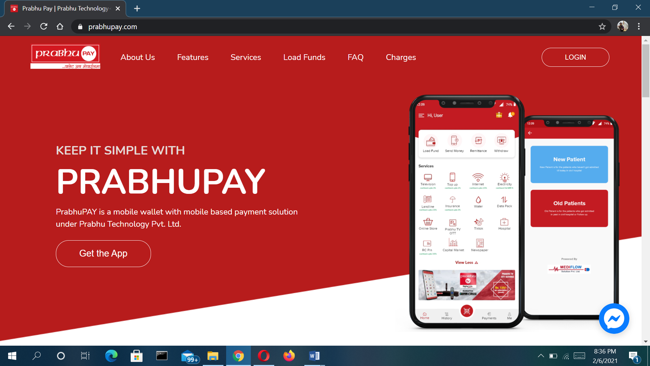

1. **Prabhu TV**

PRABHU TV – call sign is licensed by the government of Nepal and promoted by Prabhu Group to operate the 2nd generation Digital Video Broadcasting (DVB-T2) in Nepal. its network will have a nationwide footprint and will deliver high quality 24/7 wireless digital TV service to consumers 365 days a year.

DVB T2 wireless platform will distribute digital signals from PRABHU TV broadcast stations and international TV channels to TV viewers across the country. With the purchase of one of Prabhu TV's authorized set top boxes and a simple antenna, TV viewers will have access to all local broadcast TV outlets. Additionally, an array of International TV channels (both SD and HD) and specialty programs will be accessible for a minimal fee.

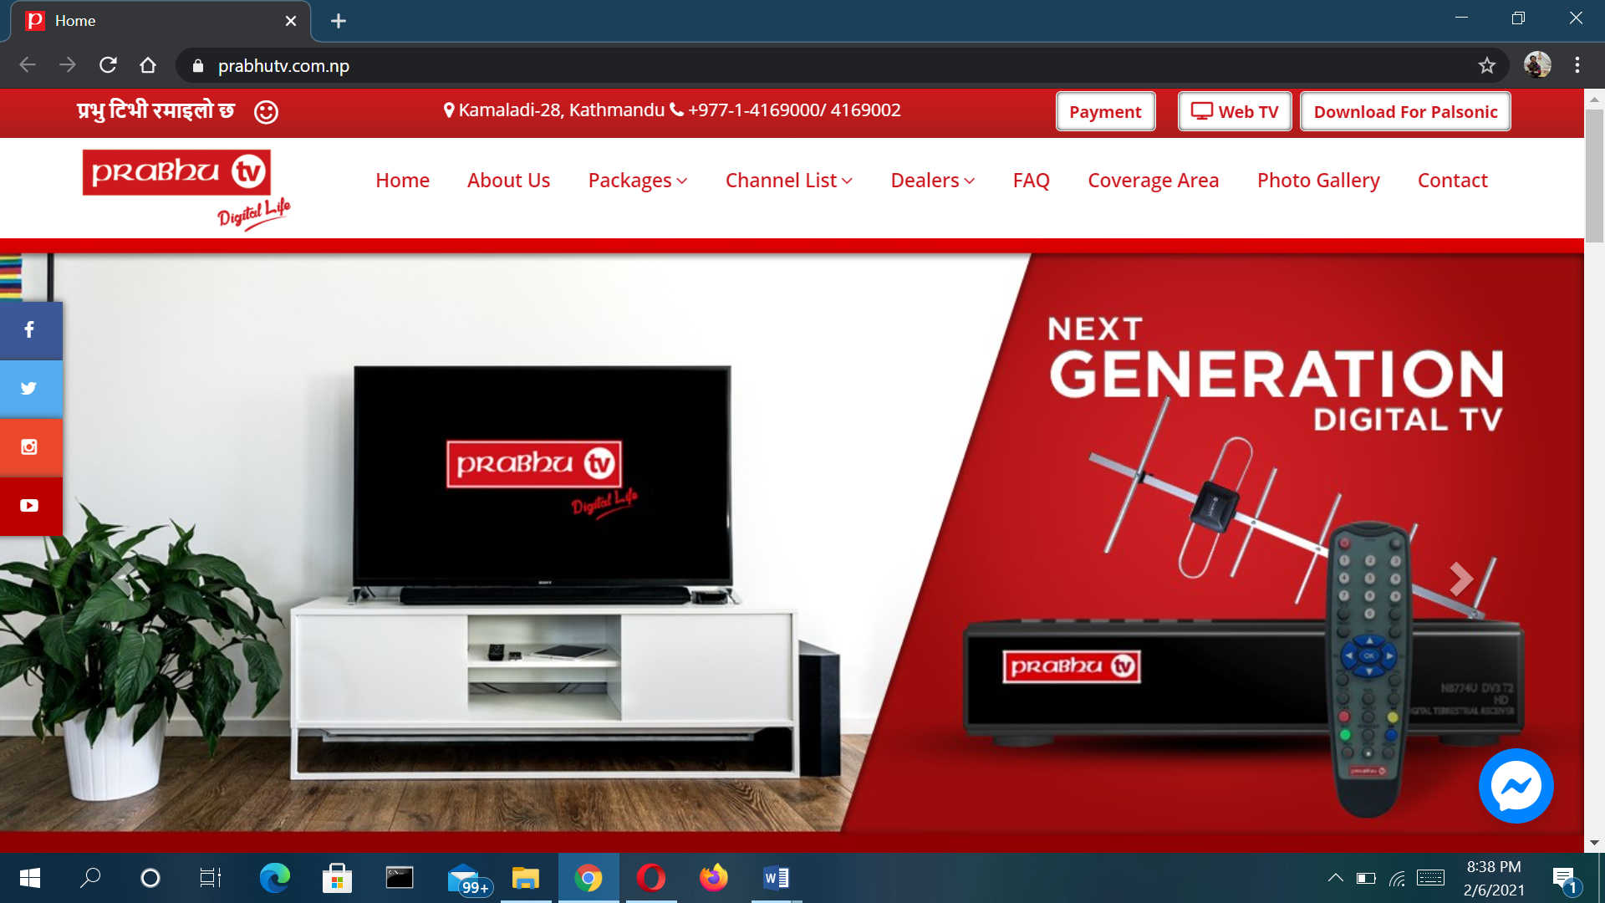

**Project Charter and Scope statement**

|  |  |
| --- | --- |
| **Project Title** | **Prabhu Store** |
| Project Manager | Dipesh Tha Shrestha  Dipeshthashrestha@gmail.com |
| Date of Authentication | June 14 2020 |
| Project start Date | June 15 2020 |
| Project Deadline | September 20 2020 |
| Goals | * Selling a service or product. * Providing product support or customer service. * Providing corporate information. * **create a differentiated customer experience to capture market share**. * **reach new customers**, * Provide a unique customer experience * Boost the efficiency of services * Make responsive ecommerce website |
| Scope | * Research. * Determining main goals. * Determining website flow. * Target Market Reserch |
| objective | * To significantly improve trade and commerce in Nepal. * To put Nepal on the global digital/electronic market. |
|  |  |

**Role and Responsibilities**

|  |  |  |
| --- | --- | --- |
| **Name** | **Postion** | **Role** |
| **Prabhu Bank Limited** | **Sponsor** | **Sponsor** |
| Dipesh Tha Shrestha | Project Manager | Team Member |
| Ram Shrestha | Personal Assistant | Team Member |
| Jay Thapa | Data Analysts | Team Member |
| Anajan Kc | Planning Officers | Team Member |
| Laxmi Shrestha | Finance Officer | Team Member |
| Anjal  Shyam  Dev | IT Team | Team Member |

**Project Characteristics:**

This project involves developing a website which aims to integrate all trade and commerce activities in Nepal into a single platform to enable consumers place their order online and it would be delivered to them via their delivery address provided. The name of the online shopping platform shall be known as Prabhu Store. In the future, a mobile app would also be developed for the platform in addition to the website. The project shall have the following characteristics;

* The website shall be easy to navigate. By this, users shall be able to look for the products they want to buy at ease. Also, users shall be able to access the website on their computers, mobile phones, tablets and iPads at ease.
* The website shall have an integrated online payment system with enhanced security system. The project management team shall ensure that they build a secure e-commerce platform.
* Another is the delivery options which shall all be available in the website.
* Most popular products shall be showcase and also promotion of similar related products.
* Another characteristics of the projects shall be high-resolution photos and videos. The project management team shall ensure that the website would be compatible with a high-resolution images and videos to be uploaded by suppliers.
* Again, the website shall have a user-generated reviews which means customers shall have the option to provide a feedback after receipt of goods and/or services from a buyer.
* Wish Lists where users shall be able to add a product they may need right away into it and later buy it.
* The website shall also have a find-in-store function. When a user sees a product, he/she can trace the product to the seller store and see other products the seller offers for sale.
* Also, the e-commerce website shall in addition to the above have a Frequently Asked Questions (FAQ) where some popular questions which shall be asked by users would be addressed.
* Other characteristics of the website shall include special orders, related items as well as scheduled delivery

**Objectives**

The objectives of the project shall be classified into two: Business objectives and Technical objectives. The first three points represents the business objective of the project and the last point represents the technical objectives of the project.

* To significantly improve trade and commerce in Nepal in an innovative way. Traditionally, most people in Nepal do engage in trade and commerce. What they currently need is a more improved way of doing a business which shall help them generate more revenue.
* To save individuals, businesses and organizations time. Time is a vital thing in the world of business because some companies pay their workers based on the number of hours worked. The proposed project shall offer the opportunities for businesses and other organization to sit at the comfort of their office and order stocks/materials and other materials and it shall be delivered to them.
* To put Nepal on the global digital/electronic market. The world is gradually changing to the digital market and this project shall pave way for Nepal to be part of the market.

The technical objective is to successful develop and implement a website that shall integrate all sellers in the area of trade and commerce into a single platform. This would reduce some costs in the operation of business and speed up business activities

**Project Deliverables:**

The deliverables that the client and the stakeholders expect at the end of the project is the ecommerce website. In order to achieve it, the project management team has proposed the following deliverables which in is line with a project life cycle.

The first phase of the project shall be the **Initiating Phase**. The main elements include; secure the necessary approval and resources; authorization of the project; set overall direction; define top level project objectives, commit organization to project or phase; and assign project manager. The deliverables to be achieve at this stage is the project charter, business requirements, projects scope, project assumptions and constraints.

The next is the **Planning Phase.** Also, the main element under this stage is to Define Project scope; Refine Project objectives; define all required deliverables; create frame for project schedule; provide forum for information sharing between project team members; define all required activities; identify required skills and resources; estimate work effort; risk analysis and avoidance; define and estimate all required costs; obtain project funding approval; communication plan. The project management team intend to achieve a project plan, work break-down structures, critical success factors and as well as project schedules as key deliverables at this stage.

Under the **Executing Phase,** the project management team intend to coordinate the resources, team development; quality assurance; select subcontractors; distribute information; work the plan which is to develop a website for an e-commerce or online store. The key deliverables in this phase includes actual efforts and project deliverable completion.

The fourth phase which is the **Controlling Phase** shall focus on the management of the team on the work, measurement of progress and also to monitor the performance of the team. All corrective actions shall be taken where necessary and there shall be performance report and communications. The deliverables in this phase of the project includes performance status reports, measurement metrics, risk management, corrective actions and issues management.

The last phase which is the **Closing Phase** shall focus on finalizing the completion of the ecommerce or online store website and contract close out including resolution of open items and final formal acceptance. The key deliverable under this phase is the deliverable acceptance and lesson learned.

During the project management lifecycle, project team members shall select and implement a phase product development lifecycle methodology in accordance with the laid-down procedures. A business strategy survey shall be conducted to define goals, business processes, critical factors, current environment, sizing requirements, current vendor environment, number of users, work processing requirements, other needs. The vendor shall be required to deliver design documents for authentication, reporting, and the database feeds. The online shopping website shall be developed based on the specifications agreed on. Users will test system functionality, performance, reporting accuracy and response times. The vendor will be required to deliver design documents for authentication, reporting, and the database feeds.

**Project Schedule:**

The team is expected to spend about thirteen weeks to start and complete the project. The project schedule varies as the project moves on the next phase. At the phase one, four, six and seven of the projects, the team shall be working on the project from Mondays to Fridays and are expected to work nine hours a day with an hour and half rest. At the third phase of the project, the team shall work from Mondays to Saturdays for 9.5 hours with two hours rest. Similarly, the team shall work on the project from Mondays to Saturdays on the project during the phase three and phase five but with different working hours and same hours for launch/rest. The table below shows the project schedule.

|  |  |  |  |
| --- | --- | --- | --- |
| **Phase of Work** | **Working Days** | **Working Hours** | **Launch/Rest** |
| 1 | Mon-Fri | 8AM – 5PM | 1.5 HRS |
| 2 | Mon-Sat | 8AM – 5:30PM | 1.5 HRS |
| 3 | Mon-Sat | 8AM – 6PM | 2 HRS |
| 4 | Mon-Fri | 8AM – 5PM | 1.5 HRS |
| 5 | Mon-Sat | 7AM – 5:30PM | 2 HRS |
| 6 | Mon-Fri | 8AM-5AM | 1.5 HRS |
| 7 | Mon-Fri | 8AM – 5PM | 1.5 HRS |

**Project Milestones:**

The table below lists the Milestones for this project, along with their estimated completion timeframe. The project shall commerce of June 15 and it is expected to be completed in 13 weeks.

|  |  |  |  |
| --- | --- | --- | --- |
| **Phase** | **Requirement** | **Time frame** | **Estimated time of completion** |
| 1 | Information Gathering | One week | June 19 |
| 2 | Planning | Two weeks | July 4 |
| 3 | Designing | Two weeks | July 18 |
| 4 | Content and Writing Assembly | Two weeks | July 24 |
| 5 | Coding | Three weeks | August 15 |
| 6 | Testing, and review launch | Three weeks | September 5 |
| 7 | Maintenance | It shall be done as and when  necessary | It shall be done after the product has been launch to the general public |

At the **Step one,** the project team shall gather relevant information about the online store. The project team at this stage shall obtain a clear understanding of the future website purposes, the main goals you wish to get, and the target audience you want to attract to your site.

The **Step two,** which is the planning stage, the project team intend to create a data for the client to judge how the entire site shall look like when completed. It shall provide a clear visual of how the inner structure of the website shall look at. This shall be done using a mind mapping software. The image below shows a framework of the proposed website.

In the **Stage three,** the page layouts, reviews and the approval cycle shall be done. All the visual content such as images, photos and videos shall be created at this stage. The layout shall be an actual graphic design and its function is to represent the information structure, visualize the content, and demonstrate the basic functionality. It shall contain colors, logos, images and can give a general understanding of the future product.

The content writing and assembly stage is where the project team shall put in writing the very essence which shall be communicated to the audience of your website and add calls-to-action. Content writing also involves the creation of catching headlines, text editing, writing new text, compiling the existing text, etc., which takes time and effort.

During the **coding stage**, the project team shall begin creating the website itself. The graphic elements that shall been designed in the previous stages would be used to create an actual website. The project team intend to start creating the website from the homepage and then all sub-pages are added, according to the website hierarchy that was previously created in the form of a sitemap. Frameworks and CMS should be implemented in order to make sure that the server can handle the installation and set-up smoothly.

The **step six** involves testing of the website, review and launch of the website. Every single link in the website shall be tested in order to that there are no broken ones among them. The team shall check every form, every script, run a spell-checking software to find possible typos. Code validators shall be used to check if your code follows the current web standards. Valid code is necessary to ensure cross-browser compatibility.

The **seventh step** shall focus on the maintenance of the website which basically includes opinion monitoring and regular updating. Feedback system added to the site will allow you to detect possible problems the end-users face.

**Team Structure:**

The Project Manager shall be one person as he shall be assisted by his personal assistant in performing his duties. The data analyst team shall be comprised of two people. Similarly, the planning officers shall also be made of two people and the project shall have one finance officer and three IT experts.

Project Manager

Personal Assistant

Data Analyst Team Planning Officers Finance Officer IT Team

**To Do List:**

The responsibilities of the various team members are presented in the table below.

|  |  |  |
| --- | --- | --- |
| **Team Member** | **Name** | **Responsibilities** |
| Project Manager | Dipesh Tha Shrestha | * Activity and resource planning * Organizing and motivating a project team * Analyzing and managing project risk * Ensuring customer satisfaction |
| Personal Assistant | Ram Shrestha | * Works hand-in-hand with project manager * Represents the project manager in a meeting where necessary |
| Data Analysts | Jay Thapa | * Responsible for the information   gathering   * Providing a comprehensive analysis of the information gathered and other relevant information * Assist the project manager in analyzing and measuring the risks in the project |
| Planning Officers | Anajan Kc | * Preparing planning documentation * Communicating with relevant parties regarding the status of planning applications and queries * Keeping up to date with planning regulations, policy and legislation. * Prioritizing your workload and taking a flexible approach to changes in direction. |
| Finance Officer | Laxmi Shrestha | * Preparation of budgets * Managing records and receipts * Preparing invoices * Resolve any financial dispute that may arise in the project. |
| IT Team | Anjal  Shyam  Dev | * Responsible for the content writing and assembly * Responsible for the coding * Responsible for the testing and   maintaining the website |

**Communication Plan:**

The Communications Plan outlines the roles and responsibilities of participants in the dissemination, review and approval of project information. The communication strategy covers all the informational needs of the project stakeholder community. Many will receive routine information about the project. Others will be able to visit the project site and obtain the specific information that they are seeking and all may receive ad hoc communication from the project team at any time depending on the need. A communications plan that is well implemented will help manage expectations of the project, assure appropriate levels of communication with internal and external project stakeholders, provide relevant, accurate, consistent information at all times and help generate and sustain enthusiasm and support for the project.

The Project Manager shall meet the owner of the project every two weeks to review project progress, deliverables/milestones, provide direction. The Project Manager is also required to report on the overall status of the project on a monthly basis, per standard DoIT proce dures. Also, specific requests for expenditure authorization shall be forwarded to the project manager for approval. If funding approval is an agenda item on the team meeting, the request and associated justification for spending shall be discussed and approved in the meeting. If funding approval is required in a timeframe that does not coincide with the team meeting schedule, it is the responsibility of the Finance Officer to send a request and justification directly to the Project Manager for Approval. All team meeting shall be documented for future reference.

**Site advantage:**

* Save Time
* Save Fuel
* Save Energy
* Comparison of Prices
* 24/7 Availability
* Hate Waiting in Lines
* Too Ashamed to Buy
* Easy to Search Merchandise You Want to Buy

**Resources Demands**

In order to build a successful online store, the project team shall require the following resources. For the purpose of the project, the resources listed below shall be referred to as WBS001, WBS002, WBS003, WBS004 and WBS005 respectively.

1. A domain name. that is an address where internet users can access the online shopping website.
2. A hosting provider shall also be needed as it shall allocate space on a web server for the online shopping website to store files.
3. An integrated payment processor shall also be needed which shall enable customers to pay for their products online shall be needed.
4. Another resources that shall be needed for the project is an internet data.
5. Other resources that shall be needed are electricity, computers and accessories, video and photo editor software and other miscellaneous expenses.

**Procurement Plan**

The nature of the project requires that main resources needed shall be bought online and it is also intangible. The domain name for the website, hosting provider, integrated payment processor and internet data are all intangible resources and are relevant as far as the creation of the online store is concerned. The IT team shall initiate a request for the resources needed and the technical, timing, quality of the resources and the constraints shall all be discussed. Having finish with these processes, the request shall be approved by the Project Manager signifying the purchase authority. A bid shall then be made, in the case of computers and accessories as well as the photo and video editing software. A contract shall be made after the parties reaching a conscious and then the resources shall be purchase. All the resources needed for the online shopping project shall be purchase as and when necessary.

**Cost Management Plan**

The cost management plan shall provide a comprehensive analysis of the cost that is expected to be incurred should the project takes place. The budget and the cost plan of the proposed project shall be discussed.

**Budget**

The table below presents the budget for the project. The WBS001 and WBS002 shall be renewed annually.

|  |  |  |
| --- | --- | --- |
| **Identifier** | **Work Package** | **Cost ($)** |
| WBS001 | Software | 500.32 |
| WBS002 | Software | 3116.57 |
| WBS003 | Software | 1007.85 |
| WBS004 | Software | 209.66 |
| WBS005 | Software and Hardware | 4588.19 |
| **TOTAL** |  | 9422.59 |

**Cost Plan**

The project team shall put in measures to reduce the cost of the project by cutting down spending that may not be necessarily needed. However, priority shall be placed on coming up with a quality website for the online shopping platform. All staffs of the project team have the adequate competencies and so no external/professional service shall be required. Prabhu Bank shall be managing the budget and shall provide a budget update to the project team as the project moves through the various phases and shall ensure that the team do not exceed the budget prepared.

**Site Uses:**

People uses this site or website for

* Faster buying process.
* Store and product listing creation.
* Cost reduction.
* Affordable advertising and marketing.
* Flexibility for customers.
* No reach limitations.
* Product and price comparison.
* Faster response to buyer/market demands.

**Site features:**

* Long scrolling webpages
* Video content will overtake written content
* Design with data
* Local search will get more local
* Focus on responsive
* Search engine optimization

**Work breakdown structure.**

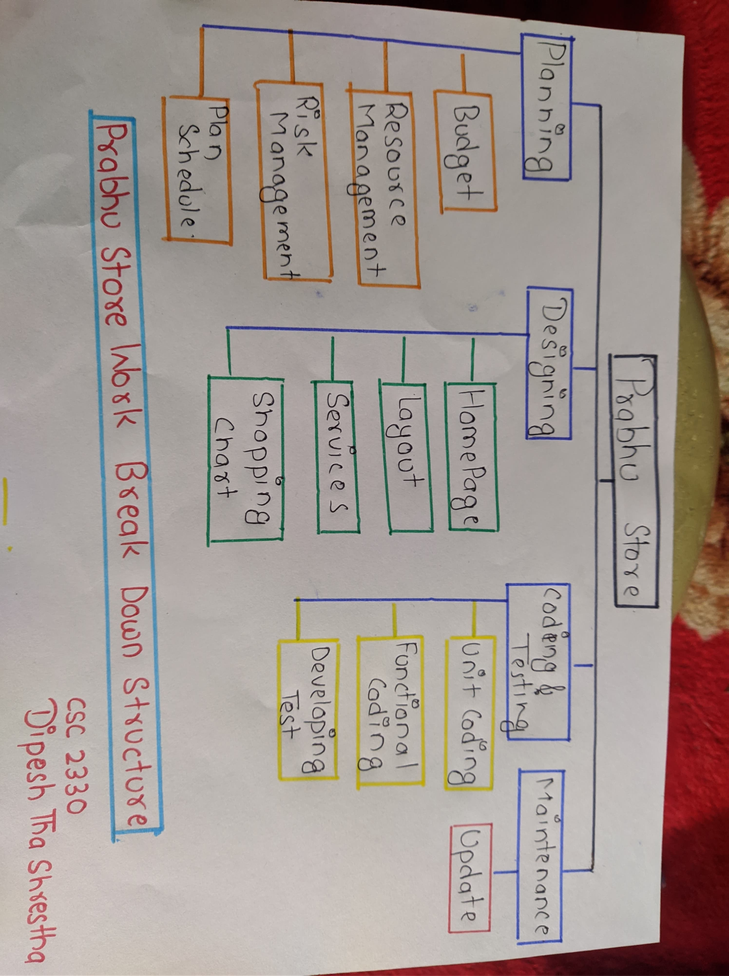

**Gantt Chart for Prabhu Store Website**

**Network Diagram**

|  |  |  |
| --- | --- | --- |
| **Activities** | **Procedure** | **Duration(days)** |
| Information Gathering(A) | - | 7 |
| Planning (B) | A | 14 |
| Designing (C) | B | 14 |
| Content and Writing Assembly (D) | C | 14 |
| Coding (E) | D | 21 |
| Testing , Review and launch (F) | E | 21 |

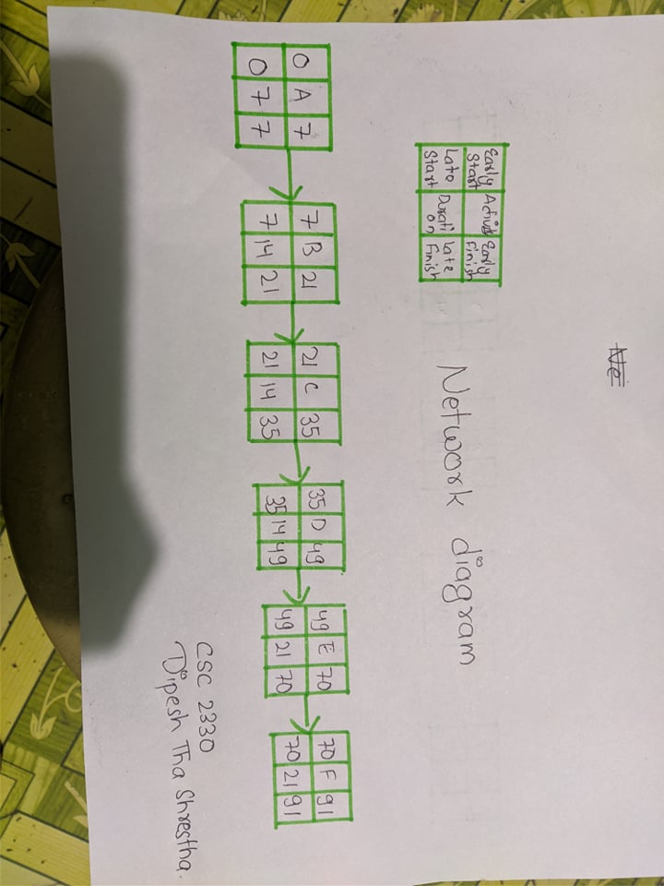

**Risk Management Plan**

This section presents the risk on the proposed project. By risk, the project team means any condition or an event that might affect the project negatively or positively should it occur. Specifically, a potential risk identification and a risk treatment plan for the proposed project were discussed.

**Risk Identification**

Risk Identification involves identifying potential risks and documenting the specific characteristics of each. Risk identification is the responsibility of all members of the project team. Any activity or issue including machine breakdown, power issue, slow in internet connect, sickness on the part of the team, lateness, defect in material, delay in the receipt of resources, bug issues, issues relating to testing of the website, work conflicts and among others shall be deemed as a risk as far as the development of an online shopping store website is concerned. The Project Manager is responsible for tracking risks and for developing mitigation strategies and contingency plans that address the risks identified by the team. Risk will be assessed routinely to ensure that identified risks are being dealt with appropriately and that new risks are identified and dealt with as early as possible.

Whenever there are plans there is always a risk involved. Some risks are unpredictable and some are preventable. To help some issues from rising in the project it important to always schedule meetings with the team members. Meetings with the team members shall prepare everyone for any risk factors that may occur. Another great way to help risk management issues are monthly evaluations. After completing a project, the team should analyze anything that needs to be modified. Sometimes potential risk is not recognized until the project is in motion.

**Conclusion**

The team is looking forward to developing a power online shopping website(Prabhu Store ) for the people of Nepal in order to ease some barriers that are associated with the contemporary trade and commerce issue.